Memory Tracker

Help Manual

Table of Contents

Button Functions…………………………………………………..Page 3

Menu Tabs………………………………………………………....Page 3

Demonstrations…………………………………………………….Page 4

Clear Button Demonstration…………………………………………..Page 5

Restore File Button Demonstration……………………………………Page 7

Medication Shortcut Buttons Demonstration………………………..Page 11

Save As Tab Demonstration…………………………………………Page 15

Opening and Saving a Text File Demonstration……………………..Page 20

How to Enable Word Wrap in Notepad Demonstration……………...Page 29

Button Functions

**Clear:** The Clear button will clear your entire file in the program.

**Restore File:** The Restore File button will restore your file that you cleared using the ‘Clear’ button.

**Medication Shortcut:** The Medication Shortcut buttons will allow you to quickly type in medications in the ‘Symptoms and Response to Medications’ text box. Each button has a number on it that corresponds to the appropriate medications #, assuming the medications are numerically listed.

Menu Tabs

**File**

* **Help:** The Help tab will allow you to quickly understand the features that are inside this program. If you are still having trouble understanding a feature or features, I would highly recommend that you look through the demonstrations in this help manual, starting on Page 4.
* **Message from Developer:** The Message from Developer tab will give you a brief message from the developer who made this program.
* **About:** The About tab will give you some general information about the program such as version, updates, and contact information for technical and developmental support.

**Save As:** The Save As tab will allow you to save your file once you are done, under the Save As tab, there are three different save options.

* **Save All:** The Save All option will save all of your information inside the program.
* **Save Info for Doctor:** The Save Info for Doctor option will only save the information meant to be given to a medical doctor, under the ‘Information for Medical Doctor’ heading.
* **Save Info to Tell Patient:** The Save Info to Tell Patient will only save the information meant to be told to the patient, under the ‘Information To Tell Patient’ heading.

Demonstrations

Clear Button Demonstration

If you want to clear your entire file, simply click the ‘Clear’ button to clear your file.

Your new file should look similar to the image below.

**Before**

**After**

If you would like to learn how to restore your file once you have cleared it, you can follow along with the next demonstration.

The only time you can not click the ‘Clear’ button is when there is no text in any of the text boxes. If you do, a pop-up message will appear as shown below.

Your file can also be cleared multiple times as long as there is some text in one or more of the text boxes.

Restore File Button Demonstration

If you want to restore your file that you just cleared, simply click the ‘Restore File’ button.

Your restored file should look similar to the image below.

**Before**

**After**

If you would like to learn how to clear your file before restoring it. You can follow along with the Clear Button Demonstration starting on page 5.

In addition to restoring your file once, you can also restore your file multiple times, up to your earliest revision of the file.

This being said, there are still two times that you cannot click on the ‘Restore File’ button. The first time is when you first run the program without hitting the clear button. If you do, a pop-up message will appear as shown below.

The second time is when you have already restored up to the first time you cleared your file. If you click on the ‘Restore File’ button under this condition, a pop-up message will appear as shown below.

Medication Shortcut Buttons Demonstration

In order to use this feature to its full potential, you must first type out a numbered list of your medications, similar to the image below.

Once you have typed out your list of medications, simply click on either a medication shortcut number or you can click on a Number Pad key, as long as your cursor is inside of the Symptoms and Response to Medications text box. For demonstration purposes, we will be using the Medication ‘1’ shortcut button.

Please Note: The Number Pad will only work for Medications 1-9, and you must have your Number Lock turned on to use this feature.

**OR**

If your computer does not have a number pad, you can use the number keys that are near the top of your keyboard.

Once you have clicked on the Medication ‘1’ shortcut button, your screen should look similar to the image below.

**Before**

**After**

As seen in this demonstration, the main purpose of this feature is to provide a quick reference to your medications, without having to type out the full medication name. This explanation is why it is important to have a numbered list of your medications, so that you can reference those medications using the Medication Shortcut buttons.

Save As Tab Demonstration

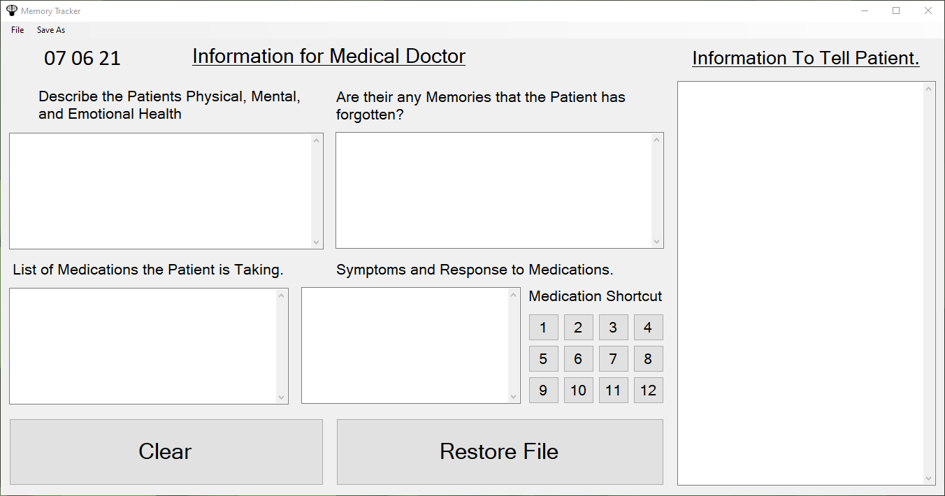

If you are looking to save your file, simply click on the ‘Save As’ tab.

Once you click on the ‘Save As’ tab, you will notice that there are three different save options.

Each of these save options are a little bit different in what they save from your file. Here is an in-depth explanation on each of the different options:

Save All: The Save All option, will allow you to save all your information that is in your file.

Save Info for Doctor: The Save Info for Doctor option, will only save your information that is under the ‘Information for Medical Doctor’ header, shown in the image below.

Save Info to Tell Patient: The Save Info to Tell Patient option, will only save your information that is under the ‘Information To Tell Patient’ header, shown in the image below.

Once you evaluate the best option that suits your needs, you can click on the corresponding option. For demonstration purposes, we will be choosing the ‘Save All’ option.

Once you click on the Save All option, a pop-up File Menu will appear similar to the image below.

Once the File Menu appears, you can navigate through the menu, and save your file to the appropriate destination of your choosing, by clicking the Save button. You can also rename the file if you would like. For demonstration purposes, we will leave the file named how it is.

After you have saved your File, you can navigate through File Explorer and select your Text File, or File. Once you open your Text File, your Text File should look similar to the image below.

You may notice that the text in this Text File does not have Word Wrap enabled, which allows the text not to roll off the screen. If you want to learn how to fix this issue, you can follow along with the How to Enable Word Wrap in Notepad Demonstration, starting on page 29.

You can also follow along with the next demonstration if you have not used Notepad before.

Opening and Saving a Text File Demonstration

There are many different ways in which a person using Windows 10 can create, edit, and save a Text File. For this Demonstration, we will be using a default Windows program called Notepad. If you prefer a different text editor, you can simply go online and search up “Text Editor” in the search bar. Please Note: if you download a different text editor, it won’t be Demonstrated in this help Manual.

In order to open the program Notepad, simply go to the Windows search bar, or click on the Windows 10 Icon with your keyboard or mouse/mousepad.

Once you click on the Windows button, type in Notepad into the search bar, and you should get this result.

You can also right click on the program and select the option “Pin to taskbar” if you want to use this program in the future.

Once you have searched or pinned Notepad to your taskbar, simply click on the program in either fashion to open it.

**OR**

Once you click on the program, the program will load similar to the image below.

In order to type inside the program, simply click on the white space and start typing.

If you are looking to save your Text File in Notepad for a later date, simply click on the File Tab and go to the Save As Tab and click on it.

Once you hit the Save As Tab, a pop-up File Menu will appear, similar to the one below.

Once the File Menu appears, you can navigate through the menu, and save your file to the appropriate destination of your choosing, by clicking the Save Button. You can also rename the file if you would like. For demonstration purposes, we will name the file Test.txt.

If you want to open your file again, simply navigate through File Explorer to find your file, then double click on the file to open it. For Demonstration purposes again, we will double click the Test.txt File.

Your file should be opened to where you left off in Notepad.

How to Enable Word Wrap in Notepad Demonstration

If you have not used the program Notepad before, I would highly recommend that you follow the Opening and Saving a Text File Demonstration starting on page 20, before looking at this demonstration.

Once you have your Text File opened in Notepad, simply click on the ‘Format’ tab.

Once you click on the ‘Format’ tab, you can then choose the Word Wrap option.

Once you click the Word Wrap option, you will notice that there is a check mark to the left of this option.

This means that Word Wrap is enabled, and your Text File should look similar to the image below.

Keep in mind that because you have enabled this feature inside of Notepad on your personal PC, Notepad will NOT automatically Word Wrap your Text File if it were to be sent to another person’s computer, and he or she were to open your Text File on his or her own PC.

So, if you are planning to send any of your files to your local doctor, I would strongly encourage you to send the Send to Doctor (Word Wrap Demo).pdf along with your files, as it contains a demonstration on how to enable Word Wrap in a Text File, so that he or she can easily read the text file you sent.